F-90 -

Functionality
An external asset acquisition is a business transaction resulting from the acquisition of an asset from a vendor. This means that you can post the asset acquisition and the corresponding vendor payable in one transaction. Using this transaction reduces the time and energy required for data entry and the possibility of discrepancies.

Scenario
You can post the acquisition of a purchased asset in several different ways, using different components of the R/3 System:
- In Asset Accounting (FI-AA) in integration with Accounts Payable (FI-AP), but without reference to a purchase order. (Illustrated here).
- In Asset Accounting, without reference to a purchase order, without integration with Accounts Payable (posting to a clearing account - with or without clearing).
- In Materials Management (MM) at goods receipt or invoice receipt (refer to Processing Asset Acquisitions in Purchasing (FI-AA/MM) and Goods Receipt and Invoice Receipt with Reference to Asset).

Requirements
None

Menu Path | Accounting → Financial Accounting → Fixed Assets → Posting → Acquisition → External Acquisition → F-90 - With Vendor
Transaction Code | F-90

1. Double Click on F-90 - With Vendor
Acquisition from purchase w.: Header Data

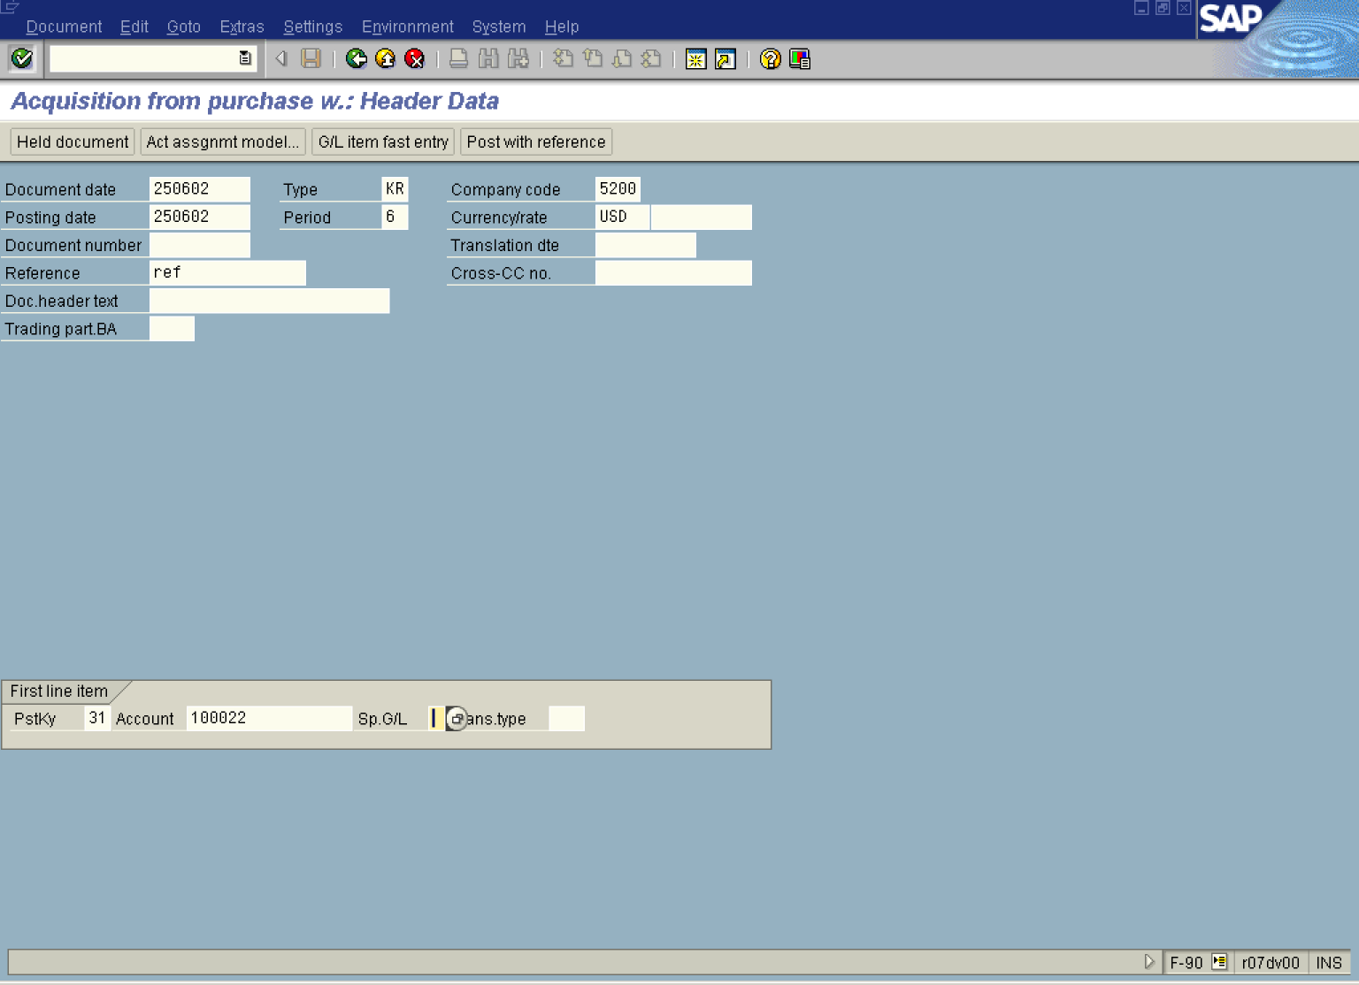
2. Update the following fields:

Field Name | Field Description | Values
Document date | Date the transaction occurred | Example: 250602
Type | The document type classifies accounting documents . | Example: KR
Company code | Code identifying a separate legal entity for which a separate set of accounts is maintained for external reporting purposes | Example: 5200
Posting date | Date that the business transaction occurred | Example: 250602
Currency/rate | Code identifying the currency used in the transaction | Example: USD
Reference | The reference document number can contain the invoice number or customer / vendor number. | Example: ref
PstKy | Two-digit numeric key that determines the way line items are posted. This key determines several factors including the: Account type and Type of posting (debit or credit). | Example: 31
Account | Code identifying the General Ledger, Vendor, or Customer account | Example: 100022
3. Click the Enter button to confirm your entries.
Enter Vendor invoice: Add Vendor item

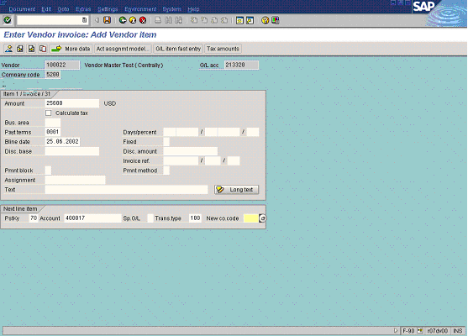

4. Update the following fields:

Field Name | Field Description | Values
Amount | Amount of the asset. | Example: 25600
PstKy | Two-digit numeric key that determines the way line items are posted.This key determines several factors including the: Account type and Type of posting (debit or credit). In this case 70 will be a debit. | Example: 70
Account | Code identifying the General Ledger, Vendor, or Customer account | Example: 400017
Trans.type | The transaction type in Asset Accounting classifies the business transaction. The transaction type controls various system activities when business transactions are posted. | Example: 100
5. Click the Enter button.
Enter Vendor invoice: Add Asset item

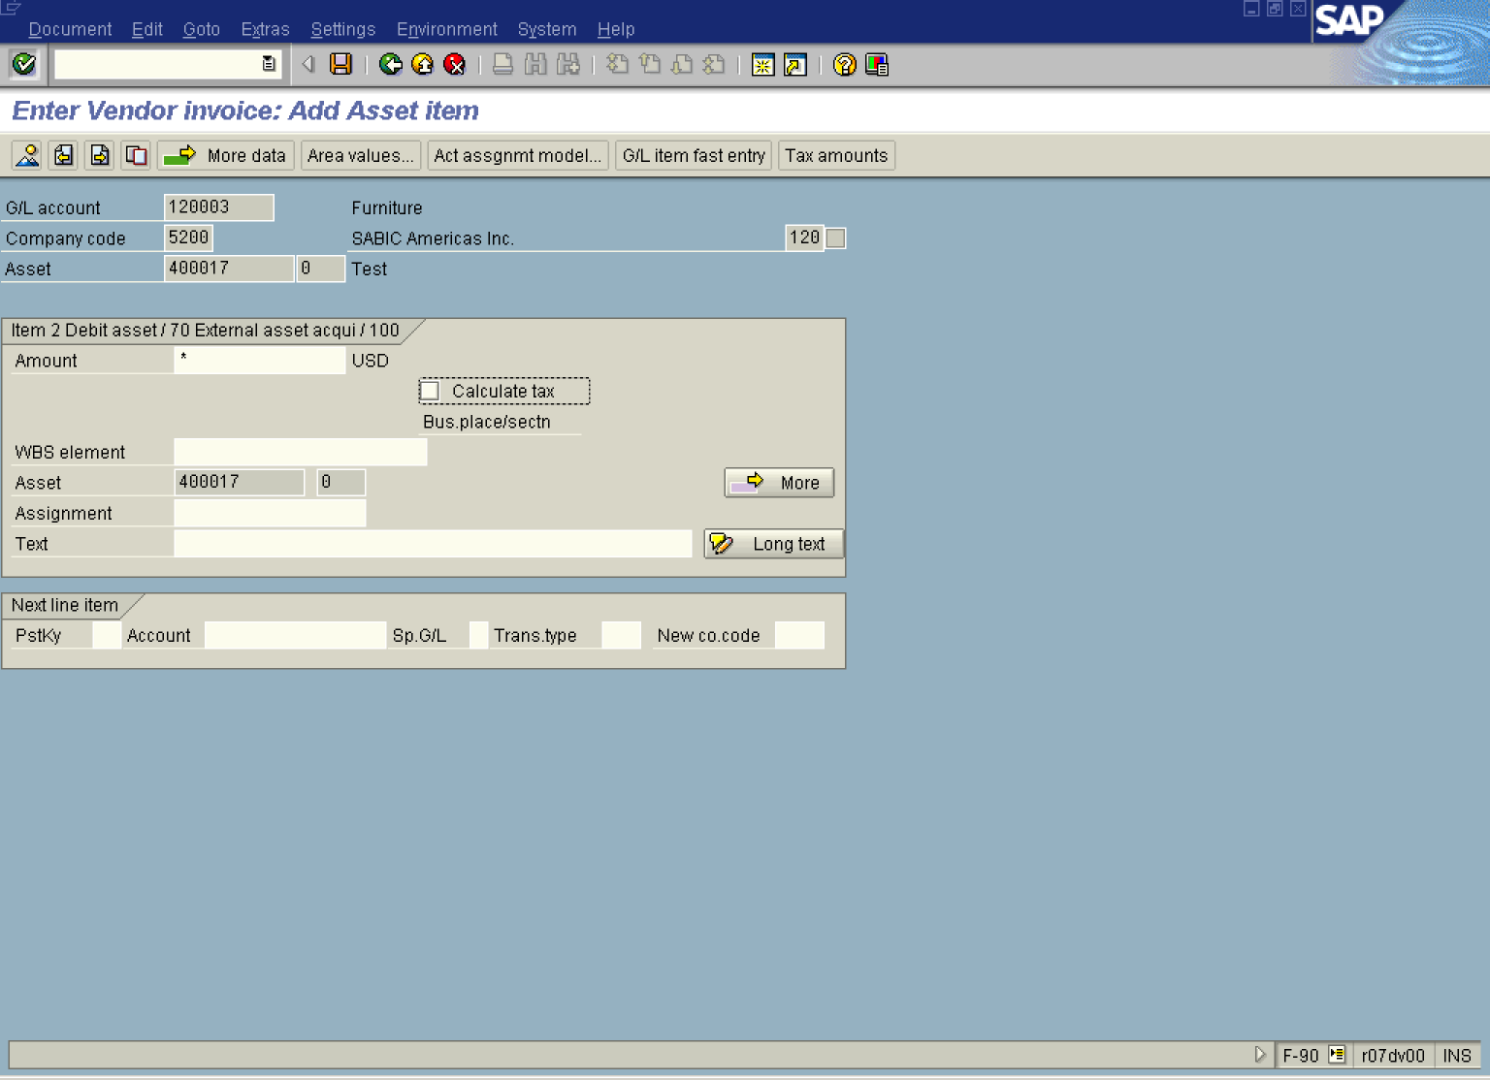

6. Update the following fields:

Field Name | Field Description | Values
Amount | Amount of the line item. Using a * will copy the amount from the first screen automatically balancing the transaction. | Example: *

7. Select DocumentSimulate. to simulate the transaction posting.

Enter Vendor invoice: Display Overview

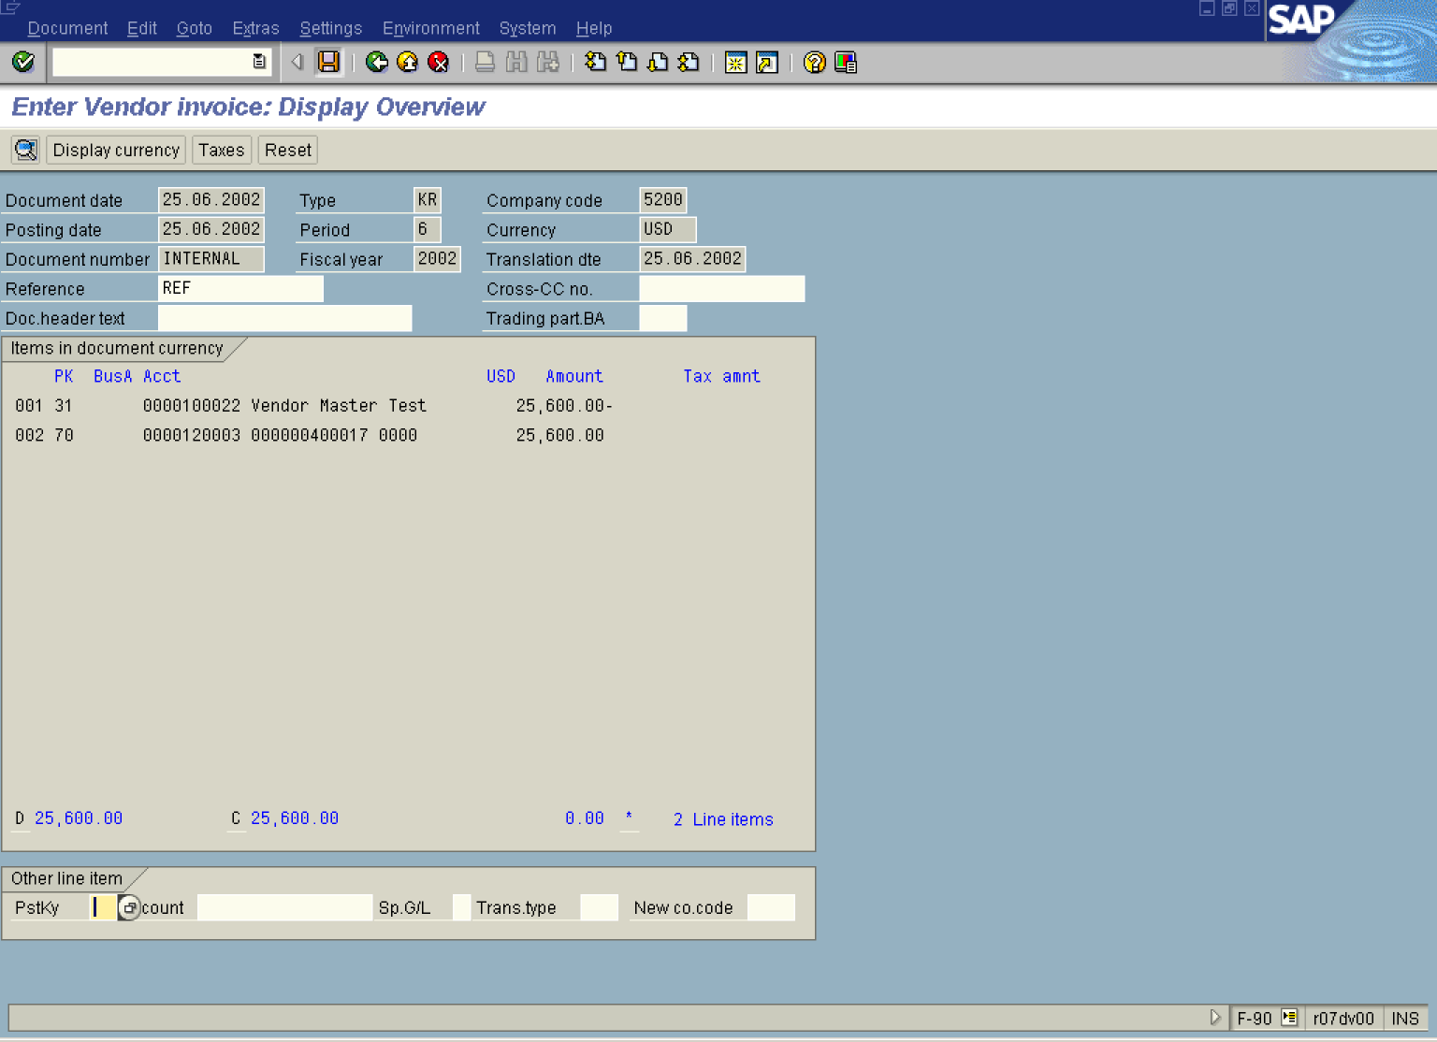

8. Click the Save button.

